Product Main Parameter/Function
Camera | Description
Chip | CV1821
Sensor | SC3335/SC4336/SC401AI/GC4653/OV4689/
Resolution | 2304x1296P、2560x1440P
Diagonal angle of view | 106°
Lens focal length | 4mm
Night vision function | Infrared night vision
AV | Description
Video coding protocol | H.264/H.265
Video code rate | 80Kbps~800Kbps (self-adaption)
Audio compression method | G.711A/AAC
Major function | Description
3D digital noise reduction | Support
Wide dynamic | Support
Backlight compensation | Support
White balance | Support
Human shape detection | Support
Motion detection | Support
Voice detection | Support
Motion Tracking | Support
Network | Description
Network Protocol | L2TP, IPv4, IGMP, ICMP, ARP, TCP, UDP, DHCP,RTP,RTSP, RTCP,UPnP, DNS,PPPoE,DDNS,NTP, FTP,HTTP, HTTPS,SIP, 802.1x
Interface | Description
Audio input and output | Audio wiring, 1 wires input, 1 wires output
Power supply | 5V⎓1A charge
Button | Reset button、One-button-alarm
Network interface | RJ45 10M/100M
Storage | Description
Local storage | Micro SD, support a maximum of 128GB
Operation | Description
Working environment | -20℃ to +60℃

CV1821+SC3335/GC4653/OV4689 Wiring diagram
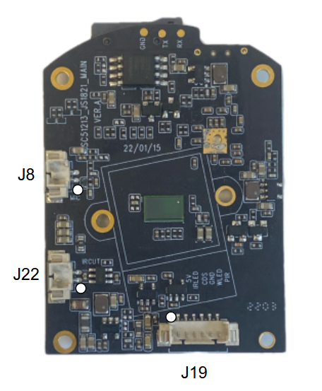
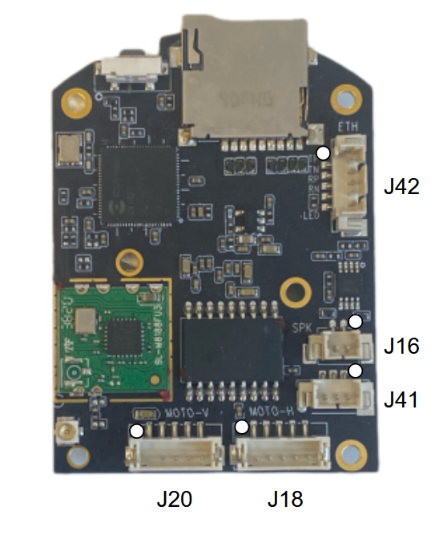

Interface | Description
J42 | 1:TXP 2:TXN 3:RXP 4:RXN 5:PHY_LED
J16 | 1:SPK- 2:SPK+
J41 | 1:KEY 2:GND 3:5V_IN
J18 | 1:MT_5V 2:MA4 3:MA3 4:MA2 5:MA1
J20 | 1:MT_5V 2:MB4 3:MB3 4:MB2 5:MB1
J8 | 1:MIC_IN 2:GND
J22 | 1:IR_OUTA 2:IR_OUTB
J19 | 1:PIR 2:WLED 3:GND 4:CDS 5:IRLED 6:5V_IN

